## STAKEHOLDER ENGAGEMENT & INVESTMENT PLAN ANNUAL REPORT 2018

#### Stakeholder Engagement

WEBG has continued its’ high level of contact with local stakeholders. The Local Community Relationship Manager, Mr Aleksandar Andjić continues to visit the development site several times each week. During 2018 WEBG employed Mr Nikola Radonjin to provide Aleksandar with local support and assistance. Nikola is from the local village of Dolovo. In addition to formal meetings (described below) Mr Andjić and Mr Radonjin have met regularly with local farmers to keep them up to date with the progress of construction work. This approach has proved to be very successful. The level of success can be measured not only by the absence of any accidents or incidents but also by the number, and speed with which claims made for damaged land and crops have been resolved. During the resolution of grievances, Mr Andjić and Mr Radonjin have held over 200 interviews and meetings with locals. At each meeting, Aleksandar and Nikola have been able to provide a lot of useful information that the participants share with their friends and families. In smaller towns/ villages, this is the best way to transfer information.

During the first nine months of the year the focus of the stakeholder meetings has moved from Transport planning to site security during construction and then preparation for operation. Three presentations were held during August 2018, these were held at Vladimirovac primary school, the Mramorak community office and the Dolovo community office. The presentations were delivered by Mr. Aleksandar Andjic and Mr Nikola Radonjin, supported by representatives of PMC and H&S Coordinators/ H&S Supervisors from the contractor team. Each event lasted for one to two hours each.

The Vladimirovac meeting was held on Thursday 23rd August and was attended by about 15 people. The Mramorak meeting was held on Friday 24th August was attended by about 20 people. The Dolovo meeting was held on Saturday 25th August and was attended by about 20 people.

Each of the meetings followed the same format and opened with a description of the status of the Project and a re-statement of the purpose of the meeting. The majority of the presentation was focused on site safety issues, particularly the unapproved entry into the WTG towers. Emphasis was placed on the potentially fatal dangers of entering an electrically ‘live’ WTG. The participants were also informed that a security company would be employed by WEBG during the operational life of the windfarm.

Following the presentation, the participants were invited to ask questions or raise any points of concern. Across the three meetings the following points were raised:

* Possible H&S hazards of working close to operational WTGs, particularly in relation to any strong electromagnetic fields or mechanical hazards.
* Consequences of lightning striking a WTG.
* Access to the site during periods of extremely stormy weather. What would be the effect of very stormy conditions on the turbines
* Possible dangers to school children if they go to see a WTG and the potential risk from fires started by accident, e.g. dropping a cigarette butt.
* Use and maintenance of public and private roads.
* Maintaining the vegetation immediately around the WTG bases.
* It was suggested that WEBG should prepare a leaflet to set-out the operational risks of the windfarm and how farmers and workers should behave when working near the turbines (particularly in bad weather conditions).
* A number of people considered that delivering presentation to school children that describes the hazards associated with the windfarm could be counterproductive. Future presentations to schools must be very cautious and thoughtful on this matter.
* Compensation claims for damage to crops.

The WEBG team are comfortable that the majority of these issues were resolved during the meetings and are pleased that local people actively participate in these meetings. WEBG have considered their comments during the preparation of the Community Health and Safety section of the OEMP. The suggestion of preparing a leaflet about the operational safety of the windfarm is welcome and WEBG are considering the content and distribution of such a document.

The next presentations will be held in March 2019 in three local communities, Mramorak, Dolovo and Vladimirovac.

At these presentations will be talking about the constructed wind farm, wind farm operation as well as the benefits and risks and the safety of locals who works at agricultural land in the area of the wind farm. During these presentations will be distributed informative leaflet about the Čibuk 1 wind farm.

#### Social Investment Activities

Whilst the nature of social investment has changed as construction began, WEBG has continued to deliver our Social Investment Plan activities in parallel with the Stakeholder Engagement Plan and Environmental and Social Action Plan activities.

The Social Investment Plan for 2018 includes the following activities:

* Donation for Football club ‘’Proleter’’ from Banatski Karlovac, Municipality of Alibunar in amount of 620 euros for the sports equipment.
* Donation for Football club ‘’Vladimirovac’’, from Municipality of Alibunar in amount of 1,200 euros also for the sports equipment.
* Donation for Cultural centre ‘’Vladimirovac’’ in amount of 2,100 euros for the reconstruction of ceiling and several rooms in the building of the Cultural centre.
* Donation for Science centre ‘’Petnica’’, Municipality of Valjevo in amount of 4,200 euros for the purchase of the spectrometer. WEBG has paid part of the funds for the purchase of this device to the Serbian Philanthropic Forum which is collecting the funds for it. ‘’Petnica’’ (ISP) is an independent institution that deals with the development of scientific culture, scientific literacy, education and culture. ISP activities are mainly aimed at young people - the students, as well as teacher training in new techniques, methods and content in the field of science and technology.
* Donation Agreement with Faculty of Civil Engineering of 3,000 euros for carrying out experimental research and professional development of the Ph.D. student of the Faculty of Civil Engineering of the University of Belgrade, Mr Aljoša Filipović, with the goal of preparing a doctoral dissertation. The funds are intended for the purchase of measuring equipment, payment of service activities necessary for carrying out experimental research as well as the costs of professional development (conference fees, software licenses, literature, etc.) and other things which are in purpose of completion of the research and promotion of its results.

The total amount of these donations is **11,120 euros** for 2018.

WEBG working on that in 2019 to donate more funds for educational purposes and help students in their future project.

Plan for SIP in 2019 will be presented in the next amendment to the SEP.

**Photolog and documentation**

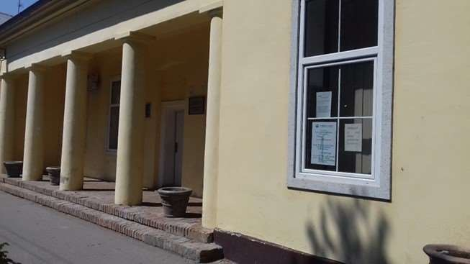

**Photo 1 – Placed posters in Vladimirovac**

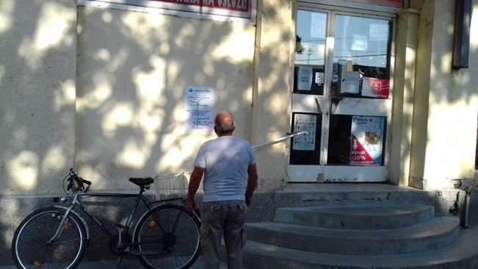

**Photo 2 – Placed posters in Mramorak**

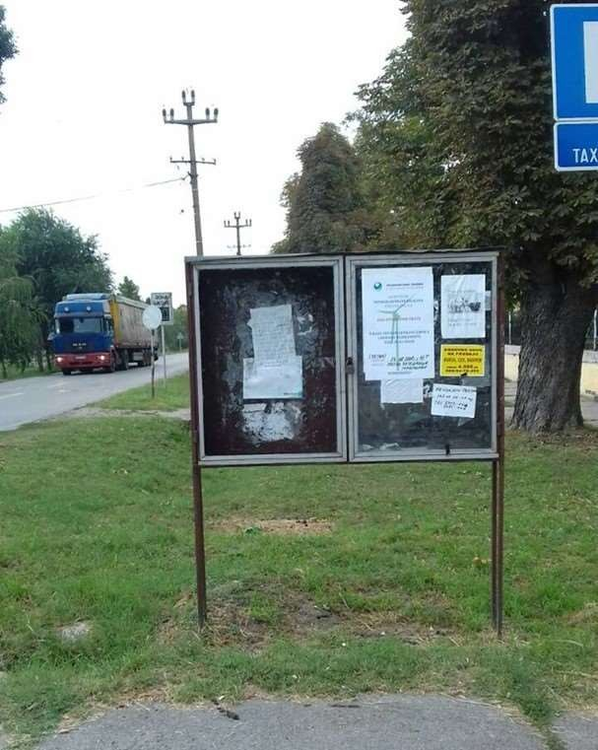

**Photo 3 – Placed posters in Dolovo**

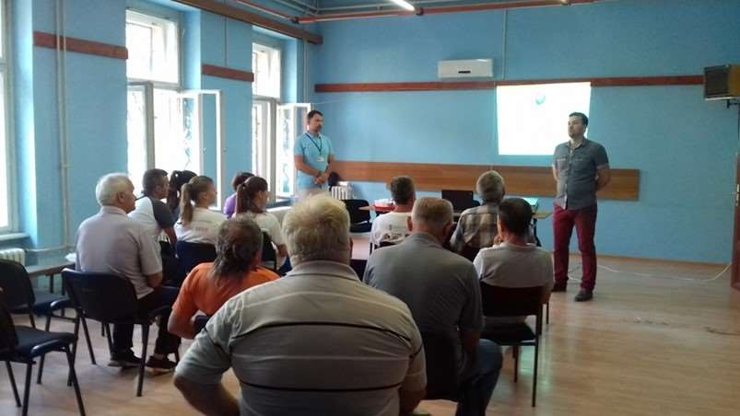

**Photo 4 – Presentation in Dolovo**

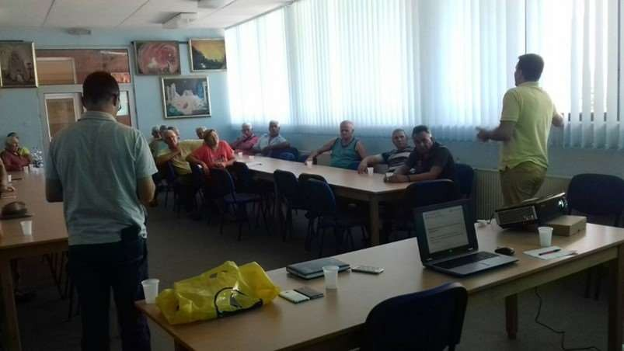

**Photo 5 – Presentation in Mramorak**

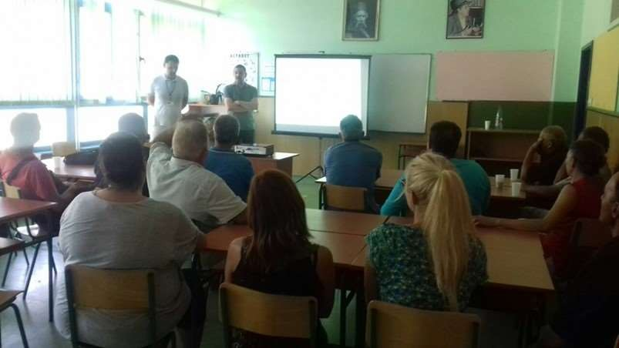

**Photo 6 – Presentation in Vladimirovac**